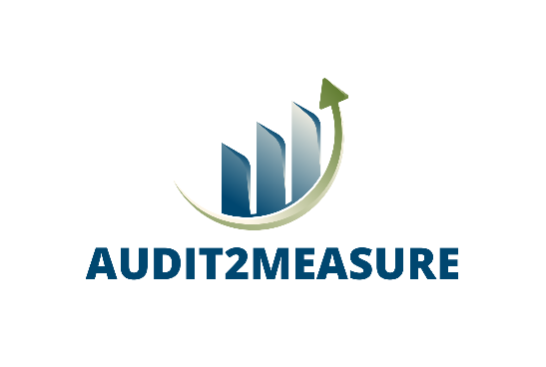

PRESS RELEASE
For immediate release
6 countries join forces to help companies “get things done” saving energy
Amsterdam, November 2022 – The European-funded project AUDIT2MEASURE will support companies in turning energy audits into actionable plans. For the next 3 years, 10 partners from 6 countries will focus on taking down barriers to the uptake of Energy Saving Measures (ESM), thus accelerating their response to the present energy context.
Energy prices reach new heights across Europe and fears for gas shortages lead to the roll-out of emergency plans and measures that affect citizens, companies, and governments at all levels. The growing push towards the energy transition prompted a spread of energy audits - which have shown to be a proven tool to tell companies where to start their interventions for better energy efficiency -, however, studies show these audits seldom result in actions, with informational, behavioural, and/or economic barriers being coined as culprits. Industry continues, therefore, to be a key player in energy consumption with high economic impact in the European Union (EU).
Looking to change this trend of collective inertia, 10 partners from 6 European countries (The Czech Republic, Germany, Greece, Italy, The Netherlands, and Spain) are working on a project that aims to motivate companies to act by addressing common barriers and offering practical support.
Speeding up energy transition, multiple barriers at a time
Three main barriers may block the adoption of Energy Saving Measures in the industrial sector: lack of information (about the costs and benefits; about energy contracts; about the potential impact on the business); behavioural inertia (due to lack of interest or commitment; imperfect evaluation criteria); and economic discouragement (low capital availability; intervention-related risks; insufficient profit potential). AUDIT2MEASURE will address each by engaging stakeholders through a holistic approach which focuses on clarifying the auditing process and resorting to using success cases as replicable examples.
AUDIT2MEASURE starts from an engagement principle called “Audit2Action”, which draws opportunities from audits and turns them into real plans of action. Among the expected project outcomes is a direct, hands-on, capacity building programme designed to engage professionals of all seniority levels, in- and outside the decision-making flow. This programme will advocate for the benefits of implementing at least 125 measures in different industrial fields, thus encouraging the execution of action plans after every energy audit.
As much as 60 companies will be engaged in AUDIT2MEASURE, invited to share experiences with energy audits and their implementation through a common Knowledge Exchange Space to help motivate others and allow for strategic comparison and replication. Through this combined approach, AUDIT2MEASURE is expected to increase the implementation rate of ESMs following auditing processes, thus nudging the industrial sector towards a green transition.
Different industrial sectors on board
For the sake of relevance and representativity, AUDIT2MEASURE will address different industrial sectors in each country:
- In The Czech Republic, the main sectors addressed include non-metallic mineral (glass, construction products), chemical industry, iron, steel, and automotive;
- In The Netherlands, the machining sector is targeted specifically for its energy intensity and savings potential. It is one of the nation’s most profitable industries which have already shown their willingness and openness to explore the implementation of ESM;
- In Italy, the ceramic, chemical, pharmaceutical, plastic, and machinery sectors will be addressed, as they rank top for consumption and potential energy savings;
- In Spain, the non-metallic mineral, chemical-pharmaceutical, machinery, and pulp and paper sectors will be targeted mainly because their energy efficiency potential is high, and also because the amount of these industries in the country is very representative;
- In Greece, the machinery sector will be mainly targeted due to its energy intensity and savings potential, as well as the numerous companies activated in the field and the replication dynamic (production of aluminum and iron constructions, production of agricultural machinery companies and companies activated in the manufacturing of electrical equipment, among others).
For more information on the project, visit www.ieecp.org
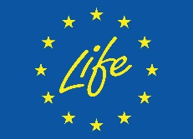
Co-funded by the European Union under project ID 101075785. Views and opinions expressed are however those of the author(s) only and do not necessarily reflect those of the European Union or CINEA. Neither the European Union nor the granting authority can be held responsible for them.

CONTACT PERSON
Marta Maia
marta@ieecp.org
+351 916 165 442

PARTNERS
